

Position Description

Senior School Classroom Teacher
Group: Senior School Classroom Teacher
Supervisor: Academic Leader
Date of Review: October 2026

About Macquarie
Established in 2001, Macquarie is a thriving Prep to Year 12 Day and Boarding Co-Educational School with a current student population of approximately 680. As one of 18 schools within the Sydney Anglican Schools Corporation, we create a Christian educational environment that integrates faith, learning, and service, guided by the principles and values of the Anglican Church.
Our mission is to develop resilient young people who make a difference through a high-quality, affordable, Christ-centred education. Our values encompass Faith, Community, Character, and Excellence, and we value our shared Christian faith, a culture of lifelong learning, an inclusive and respectful community, and our deep connection to the Central West.
Macquarie staff are our greatest asset, with high-quality teaching and stable staffing in our school. We prioritise investment in their professional development and well-being. Through regular reflection and evaluation, we build capacity in future leaders, supporting teachers in their career growth.
We have high expectations around our learning culture, behaviour, and attendance. A growth mindset, and openness to new experiences are the norm. We encourage students to strive to be their best selves, every day. We recognise and celebrate their achievements. Students proudly wear uniforms and expectations around behaviour are clear.
Macquarie boasts a rich co-curricular offering in the domains of Sports, Arts, Academics, Livestock and Service. Our Outdoor Education program is outstanding, with students in Years 3 to 12 participating in annual experiences in the great outdoors that challenge them and allow them to experience God's world beyond Dubbo.

Teaching and Learning
At Macquarie, Teaching and Learning is designed to cultivate students' independence as learners, fostering habits that enhance their engagement and equipping them with strategies to become more effective learners. Our goal is for teachers in every classroom to impart subject-specific content and nurture lifelong learners' habits and character traits. Through this approach, students at Macquarie will develop a 'Learning Mind.'
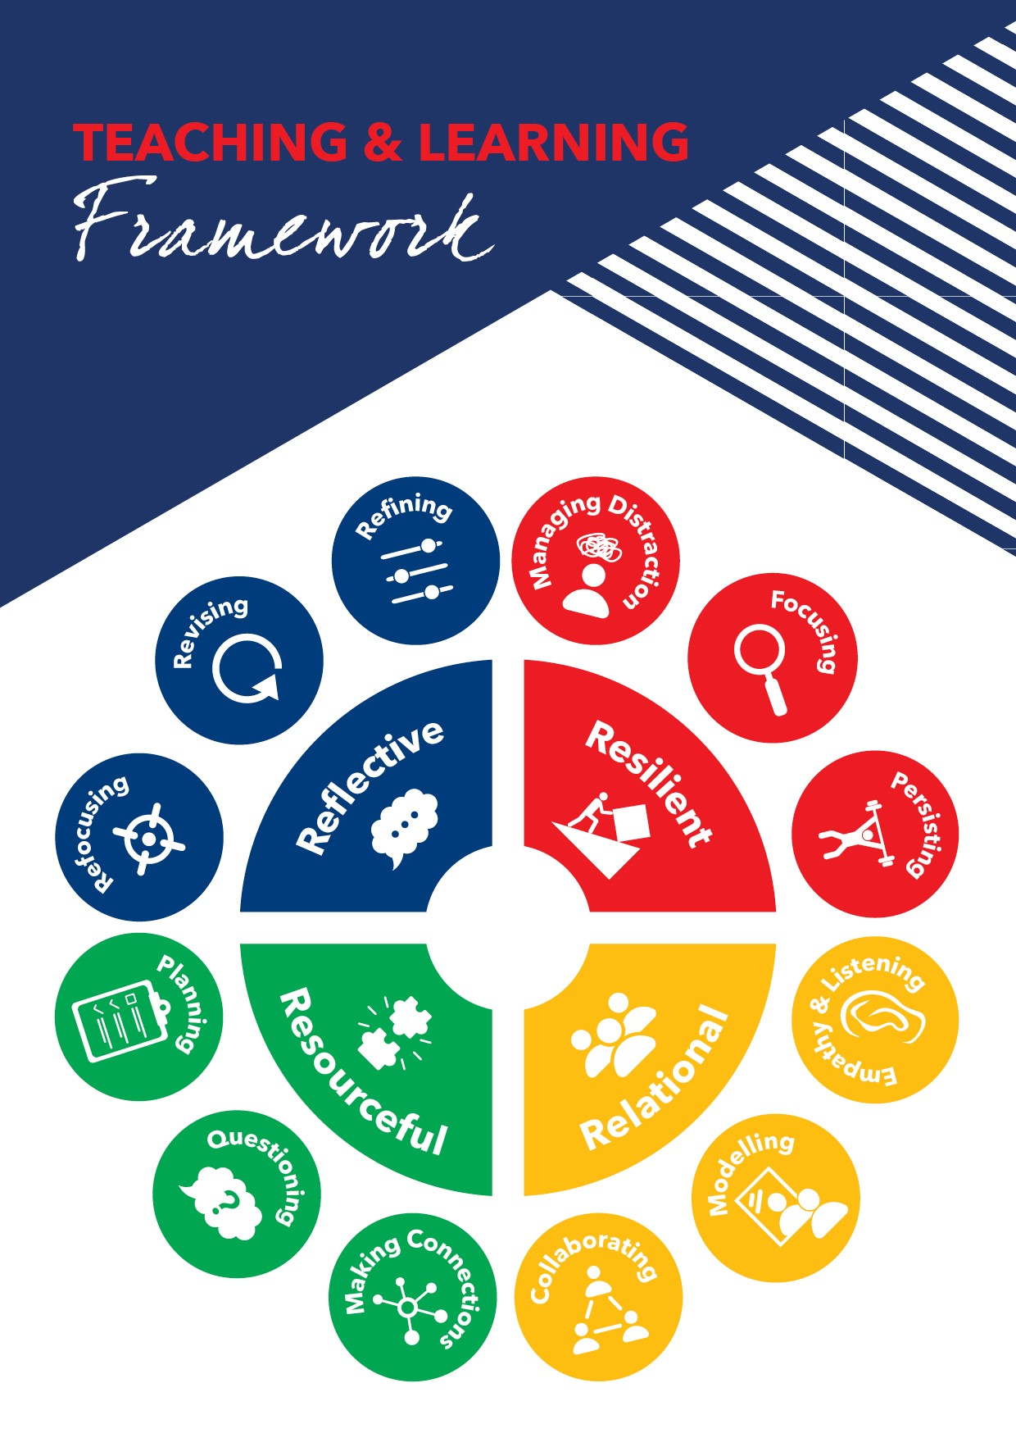
The framework is inspired by Guy Claxton’s Building Learning Power Approach, rooted in science and research. It emphasises the development of four key learning dispositions, known as the four R’s: Resilient, Resourceful, Relational, and Reflective. Each disposition is further divided into specific 'learning muscles' that can be strengthened through targeted teaching and learning activities.

Key Principles
Encourages Continuous Improvement: Both teachers and students are motivated to become better learners.
Embraces Challenges: Students learn to tackle challenges without the fear of failure.
Structured Learning: Learning is broken into manageable chunks to facilitate understanding.
Builds Confidence: Students gain confidence in their learning abilities.
Integrated Approach: The framework is embedded in all aspects of learning.
Develop Lifelong Skills: Students acquire skills that will benefit them throughout their lives.
Common Language of Learning: Provides a shared vocabulary for students to comprehend and discuss the learning process.

Role Summary
The Classroom Teacher is responsible for the implementation of the Macquarie Anglican Grammar School’s Teaching and Learning Framework through:

- Providing direction, supervision, and care for students.
- Effective delivery of the NSW curriculum.
- Maintaining professional standards.
- Effective classroom management.
- Emphasising the Christian ethos of the School.

Key Roles and Responsibilities
The Role
- Demonstrated ability to teach 7-12 in faculty area.
- Willingness to teach 7-10 in other Key Learning Areas (if required).
- Willingness to engage and promote the implementation of School initiatives that promote collaborative student engagement.

General Requirements

- Teaching classes as timetabled, using the NSW Education Standards Authority Syllabus documents.
- Actively support the School's mission as a member of the Anglican Schools Corporation through professional and personal example both in and out of the School.
- Be well-presented, well-spoken, and an ambassador for the School through personal demeanour.
- Comply with all Child Protection and Work Health and Safety legislation.

Key Accountabilities

Curriculum

- Work as a member of a Faculty.
- Plan and organise programs and lessons for effective teaching to occur using the School Curriculum Planning document.
- Participate in the Outdoor Education Program as a supervising teacher.
- Differentiate the curriculum to cater for the range of abilities, interests, and backgrounds of all students.
- Develop, construct, and implement a balanced range of assessment tasks to provide students with the opportunity to demonstrate their knowledge, skills, and ways of working.
- Evaluate assessment tasks, analyse data, and maintain records of student achievement to inform teaching practice.
- Provide timely and appropriate feedback to the individual student.
- Report constructively through open communication with parents; by way of interview, telephone conversation, email, student reporting, and the maintenance of anecdotal records.
- Become informed about students' learning characteristics and academic capabilities through examination of Individual Learning Profiles (ILPs).
- Communicate unsatisfactory academic performance and academic at-risk to your Academic Leader.
- Effective use of the School’s online learning management tools.

Professional Standards
- Develop and maintain current knowledge and expertise of pedagogy and subject disciplines, including Building Learning Power.
- Attend professional development activities to improve teaching methods, pastoral skills, and knowledge aligned to the School growth model.
- Work collaboratively as a member of the teaching team to ensure the best possible outcomes for the students.
- Meet all deadlines in a timely manner.
- Comply with the Staff Code of Conduct.
- Actively address accreditation requirements.
- Attend Faculty and Staff meetings.

Classroom Management

- Apply effective behaviour management techniques which are based on recognised theories of behaviour.
- Know and advise students of the School’s Student Code of Conduct.
- Encourage students to meet school expectations.
- Interact with students in a courteous, firm, consistent, and fair manner at all times.
- Take responsibility for recording, managing, and following-up inappropriate student behaviour.
- Be punctual, manage time, lesson planning, and assessment schedules efficiently.
- Establish a learning environment where students feel safe to participate.
- Demonstrate strategies to create a positive environment supporting student effort and learning.
- Monitor student progress and liaise with the relevant Academic Leader.
Pastoral Care
- Take responsibility for the pastoral needs, discipline, duty of care, and standards of behaviour of all students inside and outside the classroom.
- Report irresponsible or improper behaviour that is beyond normal classroom management techniques to your appropriate supervisor.

Other
- The undertaking of co-curricular activities is expected.
- Supervise additional classes as required.
- Comply with the accepted Dress Code of the School.
- Exhibit personal behaviour reflective of the ethos and Christian foundations of the School.
- Perform other reasonable duties as directed by the Principal.

Skills & Knowledge

Qualifications / Licences / Certifications
- A degree in the relevant subject area, educational qualifications, and current NESA registration.
- Current Working with Children Check (WWCC).

Essential
- A commitment to life-long learning and a passion for teaching.
- A sense of innovation and creativity.
- An enjoyment of working with young people.
- A proven understanding of recent teaching methodology, including differentiation of the curriculum.
- Strong interpersonal skills.
- A willingness to be a member of a team and work collegially with other staff members.
- A strong desire to be involved in the education of the whole child, socially, emotionally, spiritually, and academically.
- Excellent organisational skills.
- Actively support the Christian teaching of the School, and integrate their faith in all that they do.
- Work within an openly Christian environment.

Desirable
- An active commitment to the Christian faith.
- A Master’s degree in a specialised area of education or other postgraduate qualifications.

Child Safety
Macquarie Anglican Grammar School is committed to Child Safety and complies with the requirements of the Child Protection (Working with Children) Act 2012. All employees are required to comply with applicable Child Protection legislation and are responsible for ensuring that The School’s Child Safe policies, procedures and programs are at the forefront of all that we do.
All staff have a responsibility to report risk of harm concerns about children and young people, within their roles, and to provide support to children and young people.
The successful applicant is required to satisfy child protection screening and adhere to the School’s Child Safe Policy and Code of Conduct.

Work Health and Safety
Macquarie Anglican Grammar School is committed to Work, Health and Safety with the requirements of the Work, Health and Safety Act 2011. All employees have a Duty of Care, a responsibility to ensure that they and other people are safe in the workplace.
Employees must:
- take reasonable care for their own health and safety
- take reasonable care for the health and safety of others
- comply with any reasonable instructions, policies and procedures given by their employer and business
How to Apply
To apply, please submit:
1. Your CV
2. A completed application for Support Staff Application for Employment (https://www.mags.nsw.edu.au/assets/Downloads/application-for-employment-support-_-operational-staff.pdf)
3. A cover letter addressing the Position Description above.
Please submit all documentation to employment@mags.nsw.edu.au. Any questions may also be directed to this email. Applications close 24 April 2026.

